Nanyang Technological University

School of Computer Science and Engineering



Laboratory Report

CZ2003

Computer Graphics and Visualization

Lab 2

Parametric Curves

By

Teo Wei Jie (U1822263C), SS2

18 April 2020

Contents

1 Straight-Line Segment 1

2 Circle 3

3 Circle Arc 5

4 Ellipse 7

5 Ellipse Arc 9

6 2D Spiral 10

7 3D Helix 12

8 Parametric y = sin(x) 15

9 Conclusion 16

# 1 Straight-Line Segment

Figure 1 – Straight-line segment, resolution 100, parameter domain [0, 1]

Figure 1 is defined in “01_straight_line_100.wrl”. The curve is defined parametrically using the following formulas:

* x = -1 + (2 * u)
* y = 0.25
* z = 0

The formula creates a straight line from x = -1, y = 0.25 to x = 1, y = 0.25.

Figure 2 – Straight-line segment, resolution 2, parameter domain [0, 1]

Figure 2 is defined in “02_straight_line_2.wrl” using the same formula used for Figure 1.

Comparing Figures 1 and 2, there is no difference in the straight-line segment illustrated as the sampling resolution for a straight line can be as low as 2; a straight-line segment only requires 2 points to be sample.

Figure 3 – Straight-line segment, resolution 100, parameter domain [0, 5]

|  |  |  |
| --- | --- | --- |
| **Domain** | [0, 1] | [0, 5] |
| **Minimum “x”** | -1 + (2 * 0) = -1 | -1 + (2 * 0) = -1 |
| **Maximum “x”** | -1 + (2 * 1) = 1 | -1 + (2 * 5) = 9 |
| **Length** | 1 – (-1) = 2 | 9 – (-1) = 10 |

Table 1 – Comparison between Figures 1 and 3

Figure 3 is defined in “03_straight_line_0_5.wrl” using the same formula used for Figure 1.

Comparing Figures 1 and 3, the length of the straight-line segment in Figure 3 is 5 times longer than that in Figure 1, as “x” now scales to a much larger number as depicted in Table 1, with the total length of x increasing by 5 times.

# 2 Circle

Figure 4 – Circle, resolution 100, parameter domain [0, 1]

Figure 4 is defined in “04_circle_100.wrl”. The curve is defined parametrically using the following formulas:

* x = 2 * cos(2 * pi * u)
* y = 2 * sin(2 * pi * u)
* z = 0

The formula creates a circle starting from x = 2, y = 0.

|  |  |  |
| --- | --- | --- |
|  |  |  |
| Figure 5 – Circle, resolution 2, parameter domain [0, 1] |  | Figure 6 – Circle, resolution 10, parameter domain [0, 1] |

Figure 5 is defined in “05_circle_2.wrl” and Figure 6 is defined in “06_circle_10.wrl”, both using the same formula used for Figure 4.

Comparing Figures 4 and 5, the circle in Figure 5 is rendered as a straight line as there are only two sampling points, when u = 0.5 and u = 1, which translates to the angle of pi and 2 pi, which all falls on a straight line on the x-axis at y = 0.

Comparing Figures 4 and 6, the circle in Figure 6 is rendered as a decagon as there are only 10 sampling points, which form up the 10 sides of the polygon.

|  |  |
| --- | --- |
|  |  |
| Figure 7 – Circle, resolution 100, parameter domain [0, 5] | Figure 8 – Circle, resolution 500, parameter domain [0, 5] |

Figure 7 is defined in “07_circle_0_5.wrl” and Figure 8 is defined in “08_circle_500_0_5.wrl”, both using the same formula used for Figure 4.

Comparing Figures 4 and 7, the circle in Figure 7 is rough with a clear finite number of edges as compared to the smooth circle in Figure 4. Increasing the domain from [0, 1] to [0, 5] elongates the number of rotations and results in the circle in Figure 7 if the resolution remains unchanged, as the sampling points are spread across the different rotations due to the elongation.

The circle in Figure 8 illustrates the difference, as compared to Figure 7, when the resolution is increased alongside the parameter domain.

# 3 Circle Arc

Figure 9 – Circle arc, resolution 100, parameter domain [0, 1]

Figure 9 is defined in “09_circle_arc_100.wrl”. The curve is defined parametrically using the following formulas, where the angle is cut from 2pi to pi/2 as compared to the circle formula:

* x = 2 * cos(pi / 2 * u)
* y = 2 * sin(pi / 2 * u)
* z = 0

The formulas create an arc starting from x = 2, y = 0 to x = 0, y = 2.

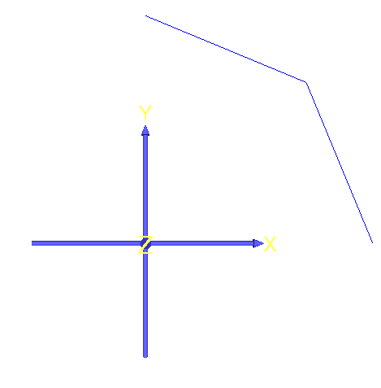

Figure 10 – Circle arc, resolution 2, parameter domain [0, 1]

Figure 10 is defined in “10_circle_arc_2.wrl” using the same formula used for Figure 9.

Comparing Figures 9 and 10, the arc in Figure 10 comprises only two straight lines as there are only two sampling points, when u = 0.5 and u = 1. When u = 0.5, x = y = 1.414, and the resulting arc is a straight line from x = 2, y = 0 to x = y = 1.414, and a straight line from x = y = 1.414 to x = 0, y = 2.

Figure 11 – Circle arc, resolution 100, parameter domain [0, 5]

Figure 11 is defined in “11_circle_arc_0_5.wrl” using the same formula used in Figure 9.

Comparing Figures 9 and 11, Figure 11 is rendered as an arc with 5 times the length as that in Figure 9, as the angle now scales from 0 to (pi / 2 * 5). The result is a circle (4 arcs) with one additional arc overlapping from x = 2, y = 0 to x = 0, y = 2 as the angle scales from

(pi / 2 * 4) to (pi / 2 * 5). No change to the resolution is necessary as the 100 sampling points being spread was proven to still be sufficient for a circle in Figure 4 (in the circle section).

# 4 Ellipse

Figure 12 – Ellipse, resolution 100, parameter domain [0, 1]

Figure 12 is defined in “12_ellipse_100.wrl”. The curve is defined parametrically using the following formulas, which is a modification of the circle formula by “compressing” the y-axis:

* x = 2 * cos(2 * pi * u)
* y = 0.5 * sin(2 * pi * u)
* z = 0

The formula creates an ellipse starting from x = 2, y = 0.

|  |  |  |
| --- | --- | --- |
|  |  |  |
| Figure 13 – Ellipse, resolution 2, parameter domain [0, 1] |  | Figure 14 – Ellipse, resolution 12, parameter domain [0, 1] |

Figure 13 is defined in “13_ellipse_2.wrl” and Figure 14 is defined in “14_ellipse_12.wrl”, both using the same formula used for Figure 12.

Comparing Figures 12 and 13, and Figures 12 and 14, the same conclusion can be drawn as that between Figures 4 and 5, and Figures 4 and 6 (in the circle section), except that there are 12 sampling points compared to that in the circle section and hence the ellipse has 12 sides.

|  |  |
| --- | --- |
|  |  |
| Figure 15 – Ellipse, resolution 100, parameter domain [0, 0.75] | Figure 16 – Ellipse, resolution 100, parameter domain [0, 0.5] |

Figure 15 is defined in “15_ellipse_0_75.wrl” and Figure 16 is defined in “16_ellipse_0_50.wrl”, both using the same formula used for Figure 12.

Comparing Figure 12 to Figures 15 and 16, decreasing the parameter domain now creates an incomplete ellipse. With a domain of [0, 0.75], the ellipse is now rendered up until ¾ of the ellipse, from x =2, y = 0 to x = 0, y = 0.5 and with a domain of [0, 0.5], the ellipse is now rendered up until ½ of the ellipse, from x = 2, y = 0 to x = -2, y = 0, as the angle now scales only up to ¾ and ½ respectively as compared to that in Figure 12.

# 5 Ellipse Arc

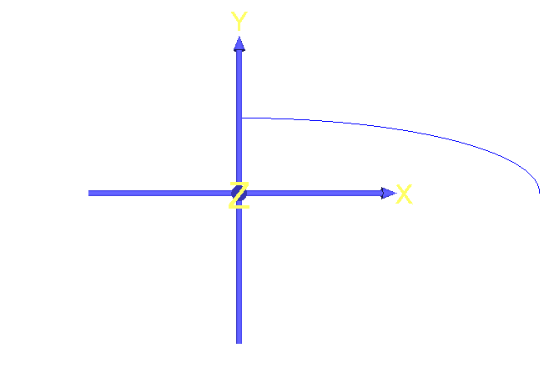

Figure 17 – Ellipse arc, resolution 100, parameter domain [0, 1]

Figure 17 is defined in “17_ellipse_arc_100.wrl”. The curve is defined parametrically using the following formulas, which is a modification of the circle arc formula by “compressing” the y-axis:

* x = 2 * cos(pi / 2 * u)
* y = 0.5 * sin(pi / 2 * u)
* z = 0

The formula creates an ellipse arc starting from x = 2, y = 0 to x = 0, y = 0.5.

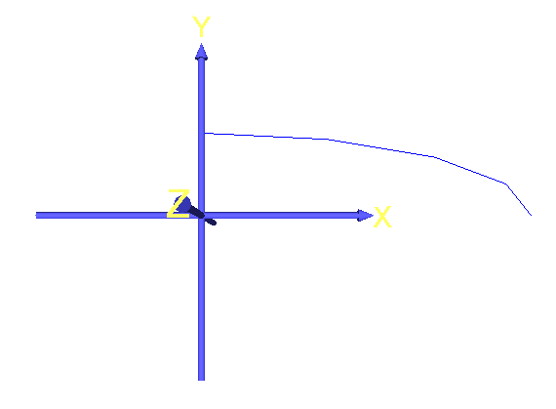

Figure 18 – Ellipse arc, resolution 4, parameter domain [0, 1]

Figure 18 is defined in “18_ellipse_arc_4.wrl” using the same formula used for Figure 17.

Comparing Figures 17 and 18, the same conclusion can be drawn as that between Figures 9 and 10 (in the circle arc section), albeit with different x and y values and with four sampling points. As such, the arc consists of four straight lines, sampled at u = 0.25, u = 0.5, u = 0.75 and u = 1.

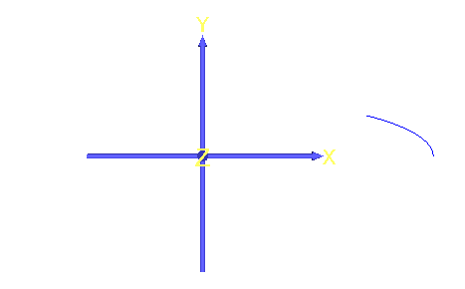

Figure 19 – Ellipse arc, resolution 100, parameter domain [0, 0.5]

Figure 19 is defined in “19_ellipse_arc_0_5.wrl” using the same formula used in Figure 17.

Comparing Figures 17 and 19, the arc is now shortened and ends at x = 1.414, y = 0.354 instead as the angle now scales until (pi / 2 * 0.5) only.

# 6 2D Spiral

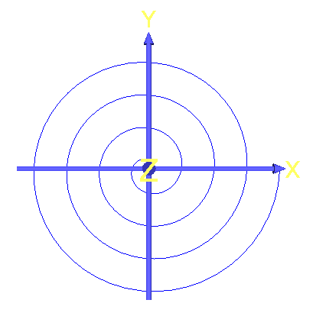

Figure 20 – 2D spiral, resolution 200, parameter domain [0, 1]

Figure 20 is defined in “20_2d_spiral_200.wrl”. The curve is parametrically defined using the following formulas:

* x = u * cos(8 * pi * u)
* y = u * sin(8 * pi * u)
* z = 0

The formulas create a spiral originating from the origin until x = 1, y = 0.

|  |  |
| --- | --- |
|  |  |
| Figure 21 – 2D spiral, resolution 2, parameter domain [0, 1] | Figure 22 – 2D spiral, resolution 20, parameter domain [0, 1] |

Figure 21 is defined in “21_2d_spiral_2.wrl” and Figure 22 is defined in “22_2d_spiral_20.wrl”, both using the same formulas used for Figure 20.

With only two sampling points for the spiral in Figure 21, when u = 0.5 and u = 1, both cases result in y = 0 as sin(4pi) = sin(8pi) = 0 and x = 0.5 and x = 1, respectively. As a result, the curve is a straight line from x = 0 to x = 1, which is obscured by the axes overlay in Figure 21, as compared to that in Figure 20.

Increasing the resolution to 20, as illustrated in Figure 22, the observation made is similar to that of the other curves. Comparing Figures 20 and 22, the spiral in Figure 22 is rough and jagged due to the low amount of sampling points.

|  |  |
| --- | --- |
|  |  |
| Figure 23 – 2D spiral, resolution 100, parameter domain [0, 5] | Figure 24 – 2D spiral, resolution 1000, parameter domain [0, 5] |

Figure 23 is defined in “23_2d_spiral_0_5.wrl” and Figure 24 is defined in “24_2d_spiral_1000_0_5.wrl”, both using the same formulas used for Figure 20.

As described in the previous curves, increasing the parameter domain elongates the length of the curves, or in the case of the circle, ellipse, and this, the rotations. As such, the sampling points are now distributed across the curve, and comparing Figures 20 and 23, the spiral in Figure 23 is jagged and arcs in the shape of a pentagon.

Increasing the resolution to 1000, there is now sufficient sampling points to create a spiral similar to that in Figure 20, as illustrated in Figure 24, albeit with many more rotations due to the elongation, originating from the origin until x = 5, y = 0.

# 7 3D Helix

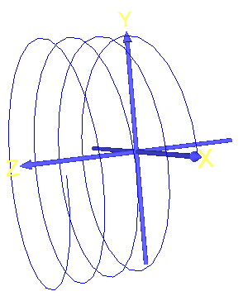

Figure 25 – 3D helix, resolution 200, parameter domain [0, 1]

Figure 25 is defined in “25_3d_helix_200.wrl”. The curve is defined parametrically using the following formulas, which is a modification of the formula for the 2D spiral:

* x = cos(8 * pi * u)
* y = sin(8 * pi * u)
* z = u

Both x and y are no longer scaled by u such that the curve does not expand in the x-axis and y-axis like the 2D spiral. With z = u, the curve now rotates outwards on the z-axis.

|  |  |
| --- | --- |
|  |  |
| Figure 26 – 3D helix, resolution 2, parameter domain [0, 1] | Figure 27 – 3D helix, resolution 15, parameter domain [0, 1] |

Figure 26 is defined in “26_3d_helix_2.wrl” and Figure 27 is defined in “27_3d_helix_15.wrl”, both using the same formulas used for Figure 25.

Similarly, with only two sampling points for the helix in Figure 26, when u = 0.5 and 1, x = 1 and y = 0 in both cases. The only variable is z = u, such that z = 0.5 and z = 1 respectively when u = 0.5 and u = 1. As such, the helix is a straight line from x = 1, y = 0, z = 0 to x = 1, y = 0, z = 1.

Increasing the resolution to 15, as illustrated in Figure 27, the observation made is similar to that of the other curves. Comparing Figures 25 and 27, the spiral in Figure 27 is a jagged mess due to the low amount of sampling points, worse so as compared to the spiral in Figure 22 due to having a lower amount of sampling point.

|  |  |
| --- | --- |
|  |  |
| Figure 28 – 3D helix, resolution 100, parameter domain [0, 4] | Figure 29 – 3D helix, resolution 100, parameter domain [0, 5] |

Figure 28 is defined in “28_3d_helix_0_4.wrl” and Figure 29 is defined in “29_3d_helix_0_5.wrl”, both using the same formulas used for Figure 25.

Similar to the observation made in the previous curves, increasing the parameter domain elongates the rotations. As such, the sampling points are now distributed across the curve, and comparing Figures 25 and 28, the helix in Figure 28 is jagged with no distinct arcing pattern. However, if the parameter domain is increased to [0, 5] from [0, 4], as illustrated in Figure 29, the helix now arcs in a consistent pentagon shape.

|  |  |
| --- | --- |
|  |  |
| Figure 30 – 3D helix, resolution 1000, parameter domain [0, 4] | Figure 31 – 3D helix, resolution 1000, parameter domain [0, 5] |

Increasing the resolution to 1000, there is now sufficient sampling points to create a helix similar to that in Figure 25, as illustrated in Figures 30 and 31, the only difference being the helix in Figure 31 is elongated due to having a slightly larger domain and having no discernible difference in the smoothness due to having a large amount of sampling points.

# 8 Parametric y = sin(x)

Figure 32 – y = sin(x) defined parametrically, resolution 100, parameter domain [0, 1]

Figure 32 is defined in “32_sinx_100.wrl”. The curve is defined parametrically using the following formulas:

* x = 2 * pi * u
* y = sin(2 * pi * u)
* z = 0

This creates a sine curve for the explicit definition of y = sin(x) where x is in [0, 2pi].

|  |  |
| --- | --- |
|  |  |
| Figure 33 – y = sin(x), resolution 2, parameter domain [0, 1] | Figure 34 – y = sin(x), resolution 10, parameter domain [0, 1] |

Figure 33 is defined in “33_sinx_2.wrl” and Figure 34 is defined in “34_sinx_4.wrl”, both using the same formulas used for Figure 32.

With only having two sampling points, the curve is rendered as a straight line, as illustrated in Figure 33, as when u = 0.5 and u = 1, y = 0 in both cases as sin(pi) and sin(2pi) = 0.

Increasing the resolution back to 10, the curve is rendered with jagged edges due to having a low amount of sampling point, illustrated in Figure 34, as compared to Figure 32.

Figure 35 – y = sin(x), resolution 100, parameter domain [0, 0.5]

Figure 35 is defined in “35_sinx_0_50.wrl” using the same formulas used for Figure 32.

Similar to the observations made in Figures 15 and 16, decreasing the domain by ½ shortens the curve by ½ as x now scales until pi instead of 2pi.

# 9 Conclusion

Multiple curves have been defined and rendered using VRML for this lab with experiments performed on the variation of resolution and the parameter domain for each curve. For this report, only one or two observations are documented for each experiment as the observations made across each curve is more or less similar and the report would be very lengthy if every observation is documented, such as documenting every experimented variation in resolution for each curve.